**Graph**

*Nodes and Vertices* - both can carry data

**Connectivity - "Graph Theory"**

- Connected graph has no disconnected nodes

- Connectivity measures the ammount of element that can be removed to get a connected graph

+ Disconnected: some vertex or group of vertices that have no connection with the rest

+ Weakly Connected: A directed graph is weakly connected when only by replacing all of the directed edges with undirected edges can cause it to be connected.

+ Connected: Here we only use "connected graph" to refer to undirected graphs. In a connected graph, there is some path between one vertex and every other vertex.

+ Strongly Connected: Strongly connected directed graphs must have a path from every node and every other node. So, there must be a path from A to B **AND** B to A.

**Graph Representations**

OOPs would use objects to represent nodes and graphs. However:

- Edge List: 2D List, each showing which nodes IDs that edge connect

- Adjacency List: 2D List, each index is node id IDs, the list containing IDs of reachable nodes

- Adjacency Matrix: Similar to adjacency list, but each list is decoder for reachable nodes [0, 1, 0, 1]

🡪 This node can reach node id = 1 and id = 3

(*if we want the index to be the node id 🡪 Also need the 0th row)*

**Graph Traversal**

1. **Depth First Search (keep going deeper)**

- Use **Stack** to mark "exploring" nodes, a method to check "seen" nodes (could be a bool in node)

|  |
| --- |
| push start node to stack  while stack is not empty:  current node = top of stack (no popping)  Mark current node as seen. Pick current node's edges:  If there is unexplored edge (how to know?): mark explored edge and get next node  If next node has been seen, continue;  Else, push next node to stack.  else if there are no more edges, pop the current node off the stack |

🡪 O(2e + v) *explore each edge twice*

- Recursion: dfs_helper(self, start_node)

|  |
| --- |
| ret_list = [start_node.value]  start_node.visited = True  for adj_edge in start_node.edges:       if (start_node.value == adj_edge.node_from.value and not adj_edge.node_to.visited):             ret_list = ret_list + self.dfs_helper(adj_edge.node_to)  return ret_list |

1. **Breath First Search (by levels)**

- Use **Queue** to mark "exploring" nodes, a method to check "seen" nodes (could be a bool in node)

from collections import deque

ret_list = [node.value]

# Your code here

queue = deque()

node.visited = True

queue.append(node)

while(len(queue) != 0):

curr = queue.popleft()

for edge in curr.edges:

if edge.node_from.value == curr.value and not edge.node_to.visited:

            edge.node_to.visited = True

                queue.append(edge.node_to)

                ret_list.append(edge.node_to.value)

return ret_list

**Eulerian Path and Cycles**

Eulerian Path: A path that traverses every edges in the graph **exactly once** (might end at another node)

**For an undirected graph**

* *Every vertex should have an even degree or only two vertices should have odd degrees.*

**For a directed graph**

* *Each vertex should have the same in-degree and out-degree except for two of them.*
* *One of these vertex will be the start vertex has one more out-going edge than in-going edges. The other one will be the end vertex which has one more in-going edge than out-going edges.*

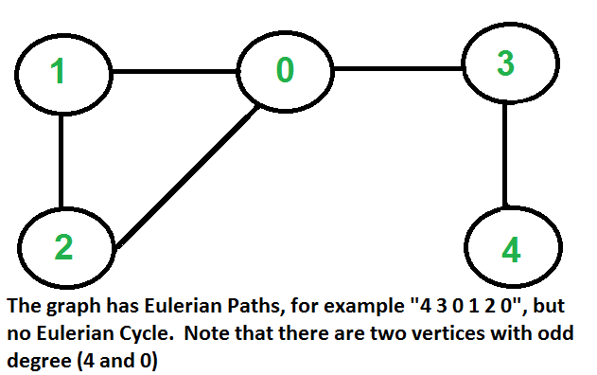

Eulerian Cycle: A path that traverses every edges in the graph **exactly once** and come back to the start

**For an undirected graph**

* *Each vertex should have an even degree.*

**For a directed graph**

* *Every vertex should have equal in-degree and out-degree edges.*

*Algorithm for **finding Eulerian Cycles** - Hierolzer Algorithm

1. We can choose any arbitrary vertex as a starting point,
2. We follow the outgoing edges of the vertex that we haven’t followed before. We can follow whichever edge we want, the only rule is not to follow previously traversed ones.
3. We should apply Step 2 until we are stuck. At some point, we will visit a vertex and there will be no edges to follow.
4. Push the vertex that we stuck to the top of the stack data structure which holds the Eulerian Cycle (Pop out of exploring path)
5. Backtrack from this vertex to the previous one
6. If there are edges to follow, we have to return to Step 2 (do not include the edges we went on)
7. If there are no vertices left to traverse, now the stack holds the complete Eulerian Cycle, and we are done. Otherwise, go back to Step 5.